I

APPENDIX I

Water meter sizing worksheet
Dallas Water Utilities

Water Meter Sizing Worksheet
H

H

I

Dallas Water Utilities
Project Information
Project Name
Project Address
Project Lot & Square
Owner’s Name
Owner’s Address
Owner’s Phone or Email
Designer Information
Designer’s Name
Designer’s Company
Designer’s Address
Designer’s Phone and/or Email
Type of Occupancy
Residential:
Single Family Home Duplex Townhouse Clustered Housing Multifamily
Mobile Home Others:
Non Residential:
Office Retail Commercial/Industrial Central Area Mixed Use Multiple Commercial Urban Corridor Others:
Hydrant Flow Test Results
Static Pressure (psi): Residual Pressure (psi): Gage Pressure (psi):
A hydrant flow test is required for a water connection 3" diameter and larger.
- Case 1: If your connection is 2" and smaller, assume a working pressure at meter discharge of 60 psi and a pressure adjustment factor of 1.0.
- Case 2: If your connection is larger than 2”, use pressure adjustment factor from Table 3.
Signature
The designer is responsible for determining required domestic, irrigation, mechanical, and fire flows in addition to the proper sizing of meters. By submitting this application, I affirm that the information provided is correct.

Designer’s Name (printed)
Signature/Date

Table 1: Water Demand Calculation
I

Domestic Demand (Continuous)
Fixture Type  (Standardized at 60 psi) | Fixture value  (gpm) |  | Number of  Fixtures |  | Total Fixture  Value (gpm)
Bathtub | 8 | x |  | =
Bedpan Washers | 10 | x |  | =
Bidet | 2 | x |  | =
Dental Unit | 2 | x |  | =
Drinking Fountain (public) | 2 | x |  | =
Faucet (kitchen sink) | 2.2 | x |  | =
Faucet (lavatory) | 1.5 | x |  | =
Shower Head (shower only) | 2.5 | x |  | =
Faucet (utility sink) | 4 | x |  | =
Urinal (flush valve) | 35 | x |  | =
Urinal (wall or stall) | 16 | x |  | =
Urinal Trough (2 ft. unit) | 2 | x |  | =
Toilet Flush Valve | 35 | x |  | =
Toilet Tank Type | 4 | x |  | =
Dishwasher | 2 | x |  | =
Clothes Washer | 6 | x |  | =
Hose (50 ft length wash down) 1/2" connection | 5 | x |  | =
Hose (50 ft length wash down) 5/8" connection | 9 | x |  | =
Hose (50 ft length wash down) 3/4" connection | 12 | x |  | =
other |  | x |  | =
Total Fixture Value |  |  |  | =
Water Flow Demand Per Fixture Value (Figures 1 & 2), gpm |  |  |  | =
Pressure Adjustment Factor (Table 3) |  |  |  | =
Water Flow Demand x Pressure Factor, gpm |  |  |  | =
Total Domestic Demand, gpm |  |  |  | =

I

Table 1: Water Demand Calculation
Contd.
Irrigation Demand (Intermittent)
 | 100  Sq. Ft. |  | Factor |  | Fixture Value  (gpm)
Irrigated Area with Spray Systems |  | x | 1.16 | =
Irrigated Area with Rotary Systems |  | x | 0.40 | =
Number of Hose Bibs (1/2") |  | x | 5.0 | =
Number of Hose Bibs (5/8") |  | x | 9.0 | =
Number of Hose Bibs (3/4") |  | x | 12.0 | =
Sub-Total Irrigation Demand (Irrigation + Hose Bib), gpm |  |  |  | =
Pressure adjustment factor (Table 3) |  |  |  | =
Sub-Total Irrigation Demand x Pressure Factor, gpm |  |  |  | =
Total Fixed Demands (if any), gpm |  |  |  | =
Total Irrigation Demand, gpm |  |  |  | =
Mechanical Demand (Continuous and/or Intermittent)
Total Continuous Mechanical Demand** gpm |  |  |  | =
Total Intermittent Mechanical Demand** gpm |  |  |  | =
*Mechanical water demand refers to the intermittent and/or continuous operation of process equipment, cooling towers, A/C systems, wash down systems, etc. It is the responsibility of the MEP to determine those demand values based on type of equipment and usage.
Fire Demand, if required by code (Intermittent)
Does the building require a fire pump? |  |  | Yes |  | No
Actual Fire Flow Demand (Per NFPA Requirements) gpm |  |  |  | =
Pump Test Demand (if required, 150% of actual demand) gpm |  |  |  | =

I

Table 2: Water Service Allocation and Meter Selection

Service Type | * Lateral Size (in) | Meter Size (in) | **Meter  Type
Small Domestic (5/8”- 2”)
Optional Irrigation
Large Domestic (> 2”)
Optional Irrigation
Bypass
Dedicated Fire Service (4”- 10”)
Detector Check Device
Bypass
Dedicated Irrigation Service
(2”- 10”)
Small Combined Water and Fire
(1”- 2”)
Domestic Water Lateral
Fire Line (Internal Sprinkler)
Large Combined Water and Fire
(4”- 10”)
Domestic Water Lateral (Max. 2”)
Fire Line (Internal Sprinkler)
Strainer
Bypass
Reference: See §2.12.5(Water Meter) of Water and Wastewater Procedure and Pipeline Design manual for
additional requirements on water service and meters
Note: * The velocity in the lateral must be ≤ 15 fps.
** See Table 2 for recommended meter type as applicable.

I

Table 3: Pressure adjustment factors (60 psi)

Working Pressure at Meter Discharge (psi) | Pressure Adjustment Factor
35 | 0.74
40 | 0.80
50 | 0.90
60 | 1.00
70 | 1.09
80 | 1.17
90 | 1.25
100 | 1.34

Source: AWWA M22: Sizing Water Service Lines and Meters, Second Edition
Note:
Working pressure at meter discharge = Static pressure in the main. Information is
obtained from a fire hydrant flow test.

A hydrant flow test is required for a water connection 3" diameter and larger. If your
connection is 2" and smaller assume a working pressure at meter discharge of 60 psi
and a pressure adjustment factor of 1.0.

Meter  Type  (inch) | Min.  Flow Rate  (gpm) | Low Normal Flow Rate  (gpm) |  | Change Over Range | High Normal Flow Rate  (gpm) | Max. Flow Rate  (gpm) | Headloss at Max. Flow  (psi)
Positive Displacement
5/8  ¾  1  1½  2 | 0.25  0.50  0.75  1.5  2 |  | 1  2  3  5  8 | N/A | 10  15  25  50  80 | 20  30  50  100  160 | 15  15  15  15  15
Turbine Class I: Vertical Shaft, Low Velocity
1  1½  2  3  4  6 | 2  3  4  6  8  15 |  | N/A | N/A | 35  65  100  220  420  865 | 50  100  160  350  630  1,300 | 15  15  15  15  15  15
Turbine Class II: Horizontal Axis, High Velocity, In-line
1½  2  3  4  6  8  10 | 4  4  8  15  30  50  75 |  | N/A | N/A | 80  100  240  420  920  1,600  2,500 | 120  160  350  630  1,400  2,400  3,800 | 7  7  7  7  7  7  7
I
Table 4: Recommended Meter Type

Table 4: Recommended Meter Type
Contd.
I

Meter  Type  (inch) | Min.  Flow Rate  (gpm) | Low Normal Flow Rate  (gpm) | Change Over Range | High Normal Flow Rate  (gpm) | Maximum Flow  Rate  (gpm) | Headloss at Max. Flow  (psi)
Multi Jet
1  1½  2 | 0.75  1.5  2.0 | 3  5  8 | N/A | 25  50  80 | 50  100  160 | 15  15  15
Compound
2  3  4  6 | 0.25  0.5  0.75  1.5 | 2  4  6  10 | 20  23  28  32 | 80  160  250  500 | 160  320  500  1,000 | 20  20  20  20
Factory Mutual (FM)
4  6  8  10 |  | 2  4  7  12 | 1  1 ½  2  2 | 700  1600  2800  4400 | 1500  3100  8000  8000 | 12  19  14  12
Detector Check (DC)
4  6  8  10 | 0.25  0.25  0.25  0.25 |  |  |  | 750  850  2000  5000

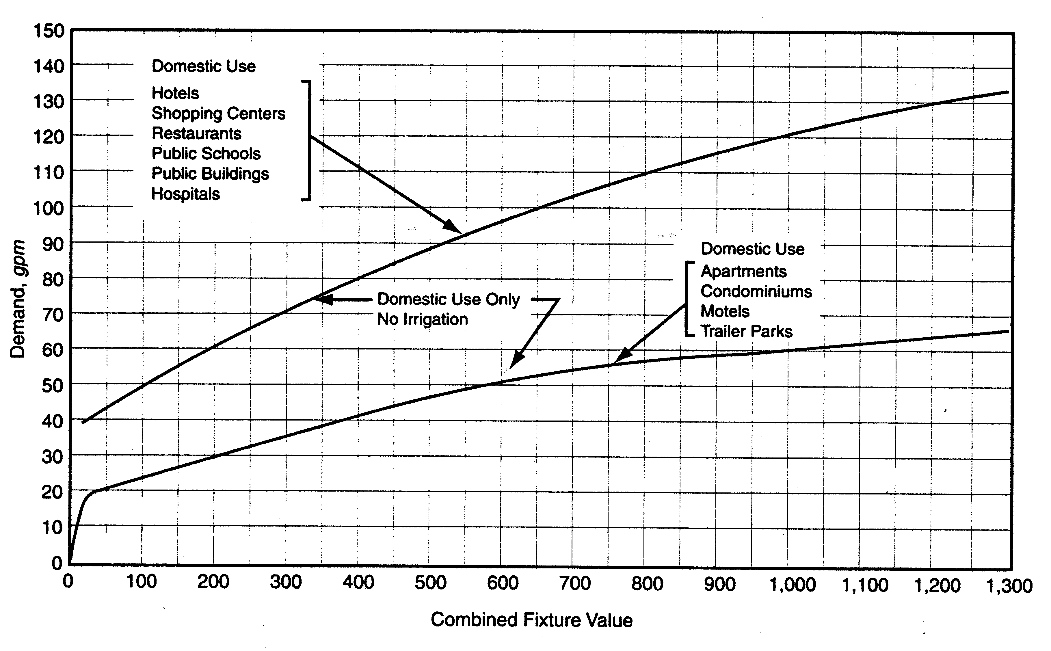
I

Figure 1: Water Flow Demand per Fixture Value – Low Range
Source: AWWA M22: Sizing Water Service Lines and Meters, Second Edition

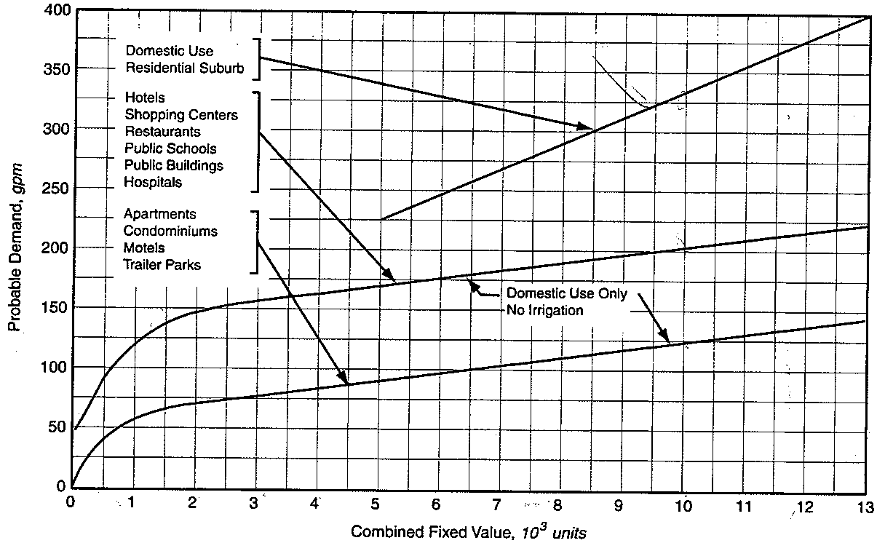

Figure 2: Water Flow Demand per Fixture Value – High Range
Source: AWWA M22: Sizing Water Service Lines and Meters, Second Edition

