HONORABLE MAYOR & CITY COUNCIL WEDNESDAY, NOVEMBER 14, 2018

ACM: Majed A. Al-Ghafry
FILE NUMBER: DCA 178-009 DATE INITIATED: December 14, 2017
TOPIC: Accessory live unit use
CITY COUNCIL DISTRICTS: All CENSUS TRACTS: All

PROPOSAL: Consideration of amending the Dallas Development Code Chapters 51 and 51A to define and establish regulations for an accessory live unit use.

SUMMARY: The code amendment will provide a person the opportunity to live where they work by allowing a residential use in conjunction with a work or business use in certain zoning districts that otherwise do not allow a residential use.

CPC RECOMMENDATION: Approval

STAFF RECOMMENDATION: Approval

Background:

- The Zoning Ordinance Advisory Committee (ZOAC) considered this issue at four public meetings: April 5, 2018, April 19, 2018, May 5, 2018 and on May 17, 2018, recommended the proposal move to City Plan Commission (CPC).
- On August 2, 2018, City Plan Commission (CPC) approved amending the Dallas Development Code, Chapters 51 and 51A, to define and establish regulations for an accessory live unit use.
- On September 17, 2018, the Economic Development and Housing Committee was briefed and recommended to forward the proposal to City Council for consideration.

General Information /Staff Analysis:

There have been recent zoning change applications requesting zoning changes from an IR Industrial Research District or an LI Light Industrial District to either a Mixed Use District or a Planned Development District in order to allow a residential use in combination with their work or business to allow a live/work opportunity.

Currently, the combination of live/work is allowed in an MU-1 Mixed Use District because a single family use is allowed in conjunction with a nonresidential use on the same lot. Some Planned Development Districts (PDs) allow live/work as specifically defined and regulated in that PD. Staff researched the surrounding cities, index cities and PDs that allow live/work units.

The PDs that allow live/work units are: PD No. 316; PD No. 317; PD No. 468; PD No. 595; PD No. 714; PD No. 808; PD No. 811; PD No. 812; PD No. 891; PD No. 908; and PD No. 929. Of these:
- Half define a live/work unit as
- an interior space that combines residential with office or retail and personal service uses.
- The other half define a live/work unit as
- an interior space with street level access that combines residential with office or retail and personal service uses.
- All consider live/work units a nonresidential use
- One PD does not allow the live/work to be combined with an alcoholic beverage establishment or a restaurant.

Nine surrounding cities were researched: Allen, Arlington, Cedar Hill, Duncanville, Fort Worth, Irving, McKinney, Plano and Richardson.
- Eight cities allow live/work in some capacity.
- Generally define live/work as a dwelling unit that is also used for work purposes.
- Work component generally restricted to office, artist’s workshop, studio, personal service or other similar uses.
- One city allows the residential to be combined with a manufacturing use.

- Types of Districts allowed:
- Central/Downtown/Business Districts.
- Special Purpose/ Planned Development Districts.
- Mixed-Use Districts.
- One city allows live/work in Medium Density Residential and Multi-Family Districts
- Owner/employee occupancy:
- Six cities require the business owner/operator or employee of the business to live in the unit.
- Six cities require the live/work unit within the same structure.

Surrounding Cities:
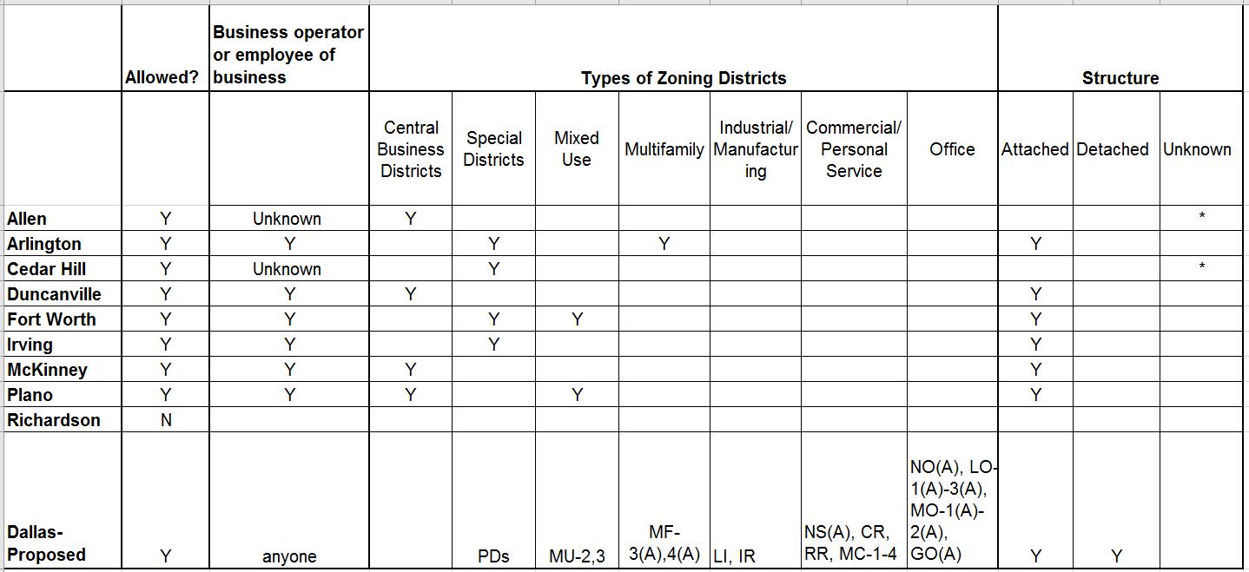

Eleven Index Cities were researched: Austin, Baltimore, Boston, Columbus, El Paso, Fort Worth, Philadelphia, Phoenix, San Diego, San Jose, and San Antonio.
- All cities allow live/work in some capacity.
- Generally define live/work as a dwelling unit that is also used for work purposes.
- Work component generally office, artist’s workshop, studio, personal service, commercial, and industrial/manufacturing uses.
- Types of Districts allowed:
- Central/Downtown/Business Districts.
- Special Purpose and Overlay Districts.
- Mixed-Use Districts.
- Commercial/Retail/Personal Service Districts.
- Four cities allow in manufacturing and industrial districts.
- Owner/employee occupancy:
- 10 cities require the business owner or an employee of the business to live in the residential portion.
- 10 cities require that the Live/Work unit is within the same structure.

Index Cities:
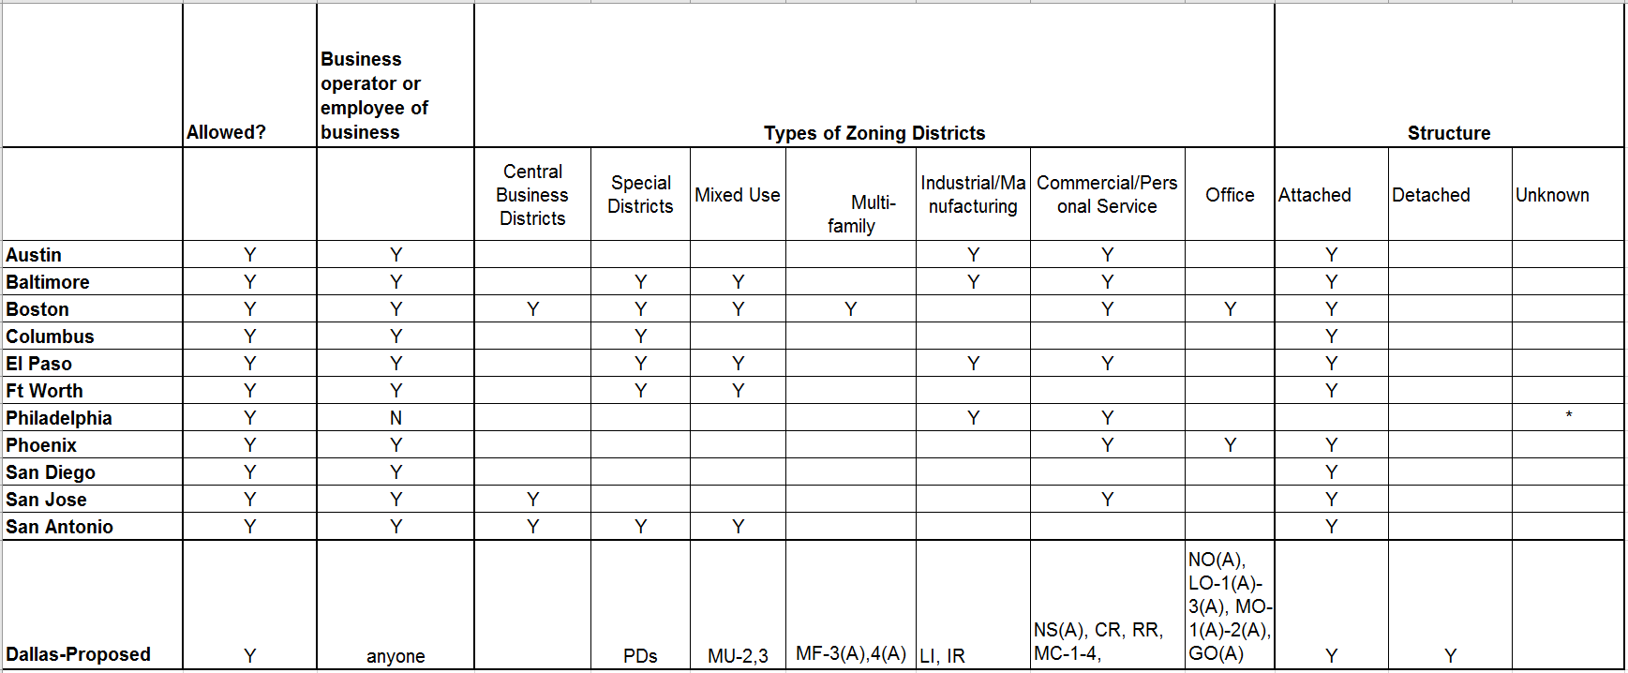

PROPOSAL:

The intent of this code amendment is to allow a residential use in conjunction and accessory to a work or business use (nonresidential use) in certain zoning districts that otherwise do not allow a residential use; providing a business owner the opportunity to live where they work.

Per Code, an accessory use must be a use customarily incidental to a main use and may not occupy more than five percent of the floor area of the main use. In this proposal, the residential component or “live unit” is a “Specific accessory use” with its own regulations allowed to be customarily incidental and used in combination with a nonresidential main use allowed in that zoning district.

Because this is an accessory use and incidental to the main use, without the main use (nonresidential use) the live unit (residential use) will not be allowed.

Definition:
Live unit means a dwelling unit accessory to any nonresidential use allowed in that district.

Provisions:
- Only one live unit per lot.
- May be attached or detached.
- Maximum floor area for the dwelling unit may not exceed the total square feet of the main use.

- Parking per Chapter 51 and 51A for the floor area of the nonresidential use (not including the floor area of the live unit). One additional parking is required for the live unit.
- Example: 6,000 square feet building with 3,000 square feet for an appliance repair shop and 3,000 for a live unit.
- Current Code requires 30 parking spaces. The total square footage of the building is parked per the main use (1 space/200 sq. ft).
- The proposal requires 16 spaces. The parking for the main use per the code (1 space/200 sq. ft) plus one additional parking space for the live unit.
- Cannot be sold separately (by metes and bounds).
- If rented, must be registered with the city’s single family rental program.

Districts:
- The following districts do not allow a single family use and allowing a live unit accessory to a main use provides the live/work opportunity.
Live Unit to be allowed in:
- Residential Districts: MF-3(A) and MF-4(A).
- Office Districts: NO(A), and LO-1(A), LO-2(A), LO-3(A), MO-1(A), MO-2(A), and GO(A).
- Retail Districts: NS(A), CR and RR.
- Industrial Districts: LI and IR.
- Mixed Use Districts: MU-2 and MU-3.
- Multiple Commercial Districts: MC-1, MC-2, MC-3, and MC-4.
- Urban Corridor Districts: UC-1, UC-2, and UC-3.

- However, it would not be allowed in CS Commercial Service Districts and IM Industrial Manufacturing Districts, because:
- CS Commercial Service Districts provide for the development of commercial and business serving uses that may involve outside storage, service, or display. This district is not intended to be located in areas of low and medium density residential development.
- IM Industrial Manufacturing Districts provide for heavy industrial manufacturing uses with accompanying open storage and supporting commercial uses. This district is not intended to be located in or near areas of residential development. Many of the uses allowed are only allowed by SUP because they are determined to be “potentially incompatible uses” and must be reviewed on an individual basis. For example: metal product treatment or processing, petroleum product refining, radioactive waste disposal services etc.

- Additionally, it would not be allowed in the following districts because these districts already allow a single family use.
- Residential Districts: A(A), R-1(A), R-1/2(A), R- 5(A), R-7.5 (A), R-10(A), R-16 (A), R-13(A), D(A), TH-1(A), TH-2(A), TH-3(A), CH, MF-1(A), 2(A), and MH (A).
- Central Area Distracts: CA-1(A) and CA-2(A);
- Mixed Use Districts: MU-1.

- Nor would it be allowed in a P(A) Parking District, because a live unit is an accessory use to the main use and the only main uses permitted in this district are gas drilling and surface parking.

- Form Districts will be reviewed separately in upcoming Code amendments.

CPC ACTION

August 2, 2018

Motion: It was moved to recommend approval of amendments to the Dallas Development Code, Chapters 51 and 51A, to define and establish regulations for a live/work accessory use with the following changes: 1) add language to require rental registration of live/work units, and 2) Live unit residency is not restricted to the property owner, business owner, or an employee of the business and their family members.

Maker: Shidid

Second: Murphy
Result: Carried: 11 to 2

For: 11 - West, Rieves, Houston, Davis, Shidid, Mack, Jung, Housewright, Schultz, Peadon, Murphy

Against: 2 - Carpenter, Ridley
Absent: 1 - Tarpley
Vacancy: 1 - District 8

Speakers: None

10-3-18
ORDINANCE NO. _____________
An ordinance amending Chapter 51, “Dallas Development Code: Ordinance No. 10962, as amended,” and Chapter 51A, “Dallas Development Code: Ordinance No. 19455, as amended,” of the Dallas City Code by amending Sections 51-4.217 and 51A-4.217; providing a definition and provisions for a live unit use; providing a penalty not to exceed $2,000; providing a saving clause; providing a severability clause; and providing an effective date.
WHEREAS, the city plan commission and the city council, in accordance with the Charter of the City of Dallas, the state law, and the ordinances of the City of Dallas, have given the required notices and have held the required public hearings regarding this amendment to the Dallas City Code; Now, Therefore,
BE IT ORDAINED BY THE CITY COUNCIL OF THE CITY OF DALLAS:
SECTION 1. That Subsection (b), “Specific Accessory Uses,” of Section 51-4.217, “Accessory Uses,” of Division 51-4.200, “Use Regulations,” of Article IV, “Zoning Regulations,” of Chapter 51, “Dallas Development Code: Ordinance No. 10962, as amended,” of the Dallas City Code is amended by adding a new Paragraph (19), “Live Unit,” to read as follows:
“(19) Live unit.
- Definition: A dwelling unit accessory to any nonresidential use allowed in that district.

- District restrictions: This accessory use is not permitted in A, R-1ac, R-1/2ac, R-16, R-13, R-10, R-7.5, R-5, D, TH-1, TH-2, TH-3, MF-1, MF-2, MH, CA-1, CA-2, P, HC, and I-3 districts.

- Required off-street parking: One additional space is required for the accessory use in excess of the required off-street parking for the floor area of nonresidential use.

- Required off-street loading: None.

- Additional provisions:

(i) The maximum floor area for the dwelling unit shall not exceed the total square feet of the main use.

- Units cannot be sold separately by metes and bounds.

- One live unit allowed per lot.

- Live unit can be attached or detached from the nonresidential use.

- Rented live units must be registered with the city’s single family rental program.”

SECTION 2. That Subsection (b), “Specific Accessory Uses,” of Section 51A-4.217, “Accessory Uses,” of Division 51A-4.200, “Use Regulations,” of Article IV, “Zoning Regulations,” of Chapter 51A, “Dallas Development Code: Ordinance No. 19455, as amended,” of the Dallas City Code is amended by adding a new Paragraph (8.1), “Live Unit,” to read as follows:
“(8.1) Live unit.
- Definition: A dwelling unit accessory to any nonresidential use allowed in that district.
(B) Districts restrictions: This accessory use is not permitted in A(A), R-1ac(A), R-1/2ac(A), R-16(A), R-13(A), R-10(A), R-7.5(A), R-5(A), D(A), TH-1(A), TH-2(A), TH-3(A), CH, MF-1(A), MF-2(A), MH(A), CA-1(A), CA-2(A), MU-1, P(A), CS, and IM districts.
(C) Required off-street parking: One additional space is required for the accessory use in excess of the required off-street parking for the floor area of the nonresidential use.
(D) Required off-street loading: None.
(C) Floor area: Except as otherwise provided in the use regulations, the maximum floor area for the dwelling unit shall not exceed the total square feet of the main use. This floor area restriction controls over the floor area restrictions in Section 51A-4.217(a)(3).
(E) Additional provisions:

- Units cannot be sold separately by metes and bounds.

- One live unit allowed per lot.

- Live unit can be attached or detached from the nonresidential use.

- Rented live units must be registered with the city’s single family rental program”
SECTION 3. That the director of sustainable development and construction shall revise the use charts to reflect the change in use regulations made by this ordinance, and shall provide these charts for publication in the Dallas Development Code.
SECTION 4. That a person violating a provision of this ordinance, upon conviction, is punishable by a fine not to exceed $2,000.
SECTION 5. That Chapters 51 and 51A of the Dallas City Code shall remain in full force and effect, save and except as amended by this ordinance.
SECTION 6. That any act done or right vested or accrued, or any proceeding, suit, or prosecution had or commenced in any action before the amendment or repeal of any ordinance, or part thereof, shall not be affected or impaired by amendment or repeal of any ordinance, or part thereof, and shall be treated as still remaining in full force and effect for all intents and purposes as if the amended or repealed ordinance, or part thereof, had remained in force.
SECTION 7. That the terms and provisions of this ordinance are severable and are governed by Section 1-4 of Chapter 1 of the Dallas City Code, as amended.
SECTION 8. That this ordinance shall take effect immediately from and after its passage and publication in accordance with the provisions of the Charter of the City of Dallas, and it is accordingly so ordained.

APPROVED AS TO FORM:
CHRISTOPHER J. CASO, Interim City Attorney

By________________________________
Assistant City Attorney

Passed______________________________

