HONORABLE MAYOR & CITY COUNCIL WEDNESDAY, NOVEMBER 14, 2018

ACM: Majed A. Al-Ghafry
FILE NUMBER: DCA 178-004 DATE INITIATED: December 14, 2017
TOPIC: Ceremonial street naming
CITY COUNCIL DISTRICTS: All CENSUS TRACTS: All

PROPOSAL: Consideration of amending Chapter 51 and Chapter 51A of the Dallas Development Code: (1) Article IX to create regulations to allow ceremonial street naming; and (2) Article I to establish fees for ceremonial street naming and amend fees for street name change.

SUMMARY: The proposal will allow for ceremonial street naming to honor an individual by adding a ceremonial plaque as a topper on street signs. Ceremonial street naming will not change the existing name of the street, addressing, or impact emergency services. Ceremonial street naming toppers will be unique in design and style, different from existing street name signs. The proposed ordinance establishes the fee for the ceremonial street naming process and amends the fee for a street name change.

CPC RECOMMENDATION: Approval

STAFF RECOMMENDATION: Approval

Background:

- On December 14, 2017, Subdivision Review Committee (SRC) approved a proposal to create regulations to allow ceremonial street naming.
- On February 1, 2018, City Plan Commission (CPC) approved amending Article IX of Chapter 51 and Chapter 51A of the Dallas Development Code to create regulations to allow ceremonial street naming.
- On April 23, 2018, the Mobility Solutions, Infrastructure and Sustainability Committee was briefed on the Ceremonial street naming proposal. The Committee recommended to forward the proposal to City Council for consideration.
- On June 13, 2018, City Council considered the proposal and remanded it back to the Mobility Solutions, Infrastructure and Sustainability Committee for another briefing.
  - Some council members expressed concern that the wording, “no street or portion of a street may have more than one ceremonial street name”, implied that different segments or blocks of a long street could not have different ceremonial names.
  - That wording has been amended to “no portion of a street may have more than one ceremonial street name” thereby clarifying that different segments or blocks of a long street may each have a different ceremonial street name.
- On September 24, 2018, the Mobility Solutions, Infrastructure and Sustainability Committee was briefed again and recommended to forward the proposal to City Council for consideration.

General Information /Staff Analysis:

During recent street name change requests at Council, it was suggested that there should be an alternative process to name a street to honor an individual other than the current street name change process.

The current street name change process requires review from fourteen departments, impacts addressing, emergency services, and mapping.

Most cities have policies to honor an individual or group for their services to local or national life through a street naming process similar to our current process. However, some cities also have an alternative process to honor individuals through supplemental signs or toppers. The alternative process is not as lengthy and does not impact addressing or emergency services. The alternative process would not cause a property owner to incur costs to change personal or business materials due to an address change as occurs with the street name change process. The supplemental signs or toppers differ from existing street name signage.

Table 1, Surrounding Cities Research:
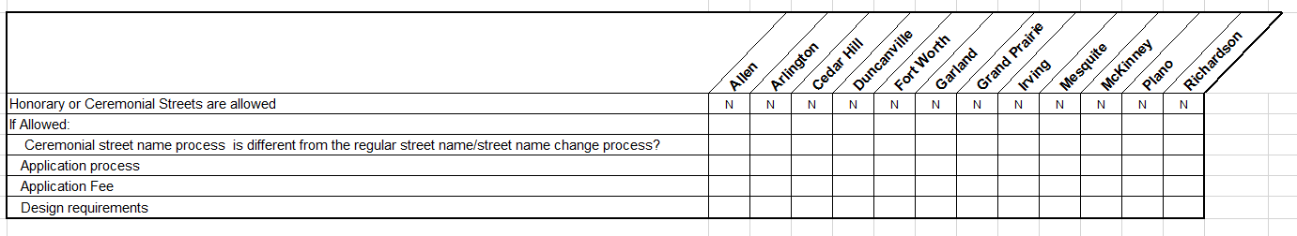

Table 2, Surrounding Cities Research:
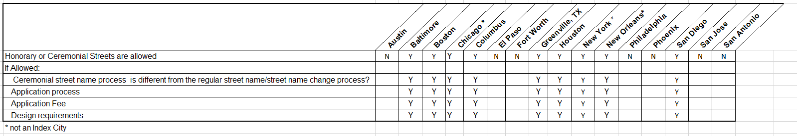

Proposal:
Ceremonial street naming commemorates individuals who have made significant contributions to the community but without causing any changes to the existing street names.

Ceremonial Street Naming criteria:
- Prospective honorees should have a minimum of 10 years community involvement and have demonstrated an extraordinary and consistent voluntary commitment and dedication to the community or who have contributed significantly to City of Dallas.
- Prospective honorees must be deceased for at least two years prior to consideration.
- Individuals who have already been honored may not be honored on another street.
- City Council, by a three-fourths vote of its members, may waive any of the above requirements.

General Provisions:
- No portion of a street may have more than one ceremonial street name.
- Ceremonial street naming cannot contain a product or be used for commercial purpose.
- Ceremonial street name ends 10 years after the effective date.
- Ceremonial street naming topper shall have “In Honor Of” as the top line.

Ceremonial Street Naming Application:
- A ceremonial street naming application may be initiated by:
- an owner of property abutting the street in a block by petition: a petition indicating that at least 51 percent of the owners of all lots abutting the street favor the ceremonial street naming; or
- by a council member with concurrence by two other council members.
- An application for a ceremonial street naming must be filed with the department on an application form furnished by the department. The application must include:
- The application fee;
- A statement of contributions made by prospective honoree, supporting documents showing the significant contributions made by the prospective honoree and meeting the ceremonial street naming criteria; and
- A boundary map showing the portion of the street proposed for ceremonial street naming.
- Ceremonial Street naming can be changed/removed or extended by the same application process as original ceremonial naming.

Ceremonial Street Naming Approval Process:
- Notice of the public hearing before the City Council must be advertised 15 days prior to the hearing and a notice of the public hearing to the abutting property owners shall be mailed no fewer than 15 days prior to the date of the public hearing. Notification signs must be posted along the street for no fewer than 15 days before the date of the hearing.
- City Council may approve or deny the application based on the testimony presented at the public hearing and whether or not it meets the ceremonial street naming criteria standards.
- The favorable vote of three-fourths of all members of the city council is required if:
- A written protest against the ceremonial street naming has been signed by the owners of 20 percent of all lots abutting the proposed portion of street.

Ceremonial Street Naming Fabrication, Installation and Replacement:
After City Council’s approval, the Department of Transportation is responsible for the fabrication and installation of the ceremonial street naming sign toppers. The City is not responsible for replacing a ceremonial street naming sign topper due to vandalism, theft, normal wear and tear.

The Department of Transportation may remove any ceremonial street naming sign topper that has become unsightly without replacing it.

Funding:
The source of funding for the implementation portion of the new Ceremonial street naming process is based on the initiation:
- Property owner initiated request: Cost (application fee, fabrication, and installation fee) is paid by the property owner.
- City initiated requests: City Council will need to identify funding for all Council initiated requests; or increase Department of Transportation budget to cover the cost of fabrication and installation.

EXAMPLE
CEREMONIAL STREET NAMING SIGN TOPPER

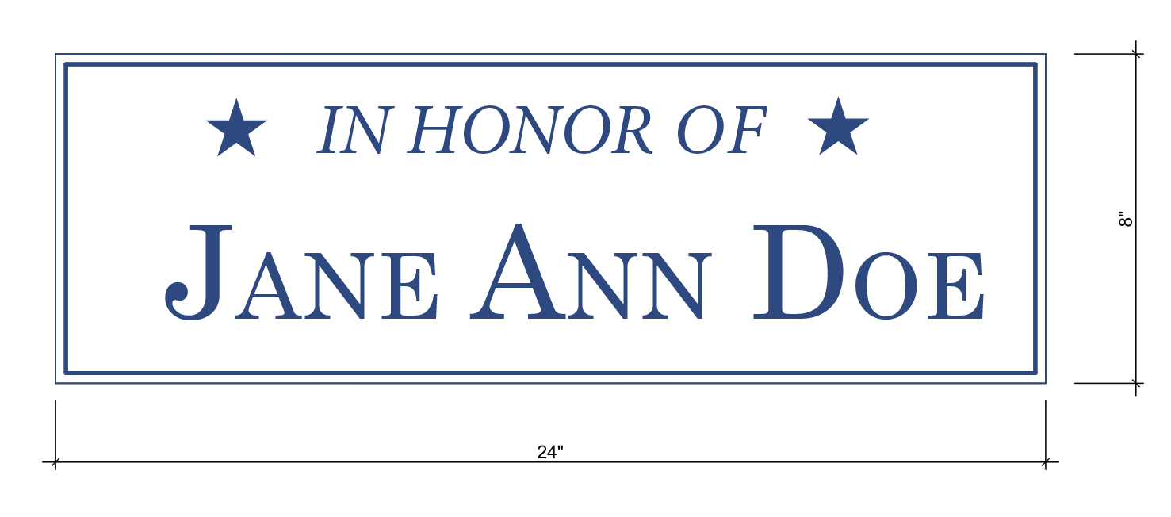

Note:
Background to be white with blue lettering.

CPC ACTION

February 1, 2018:

Motion: It was moved to recommend approval of amending Article IX of Chapter 51 and Chapter 51A of the Dallas Development Code to create regulations to allow ceremonial street naming with the following modifications: 1) amend Sec. 51A-9.506 to add at the end “Unless reapproved pursuant to a new application.” and 2) Correct a typographical error in Sec. 51A-9.503(b)(1) change 10 days to 15 days.

Maker: Jung

Second: Houston
Result: Carried: 14 to 0

For: 14 - West, Rieves, Houston, Davis, Shidid, Carpenter, Lavallaisaa, Jung, Housewright, Schultz, Peadon, Murphy, Ridley, Tarpley

Against: 0
Absent: 1 - Mack
Vacancy: 0

Speakers: None

10-1-18

ORDINANCE NO. __________

An ordinance amending Chapter 51, “Dallas Development Code: Ordinance No. 10962, as amended,” and Chapter 51A, “Dallas Development Code: Ordinance No. 19455, as amended,” of the Dallas City Code by adding a new Division 51-9.500 and a new Division 51A-9.500; providing for ceremonial street naming; amending Section 51A-1.105; providing an updated fee schedule for street name change applications; providing a fee for ceremonial street naming; providing a penalty not to exceed $2,000; providing a saving clause; providing a severability clause; and providing an effective date.
WHEREAS, the city plan commission and the city council, in accordance with the Charter of the City of Dallas, the state law, and the ordinances of the City of Dallas, have given the required notices and have held the required public hearings regarding this amendment to the Dallas City Code; Now, Therefore,
BE IT ORDAINED BY THE CITY COUNCIL OF THE CITY OF DALLAS:
SECTION 1. That Article IX, “Thoroughfares,” of Chapter 51, “Dallas Development Code: Ordinance No. 10962, as amended,” of the Dallas City Code is amended by adding Division 51-9.500, “Ceremonial Street Naming,” to read as follows:

“Division 51-9.500. Ceremonial Street Naming.

This division incorporates by reference the language of Division 51A-9.500 of Chapter 51A of the Dallas Development Code, as amended.”

SECTION 2. That Subsection (l), “Fees for a Street Name Change,” of Section 51A-1.105, “Fees,” of Article I, “General Provisions,” of Chapter 51A, “Dallas Development Code: Ordinance No. 19455, as amended,” of the Dallas City Code is amended to read as follows:

“(l) Fees for a street name change and for a ceremonial street naming.

(1) The following fees are required for a street name change.

(A) A street name change fee must be paid to the director before an application will be processed.

(B) A fee for new street identification signs must be paid to the director of sustainable development and construction within 60 days of the approval of a street name change by the city council.

(C) A fee for change of official address records must be paid to the building official within 60 days of the approval of a street name change by the city council.

(D[2]) Fee schedule.

(i[A]) Application Fee. Amount

If the street is less than one-fourth mile $1,500.00 [$750.00]

If the street is less than one-half mile but more than $2,100.00 [$1,050.00]
or equal to one-fourth mile

If the street is less than one mile but more than or $2,700.00 [$1,350.00]
equal to one-half mile

If the street is more than or equal to one mile $2,700.00 [$1,350.00]
for first mile plus $600.00 [$300.00] for each additional one-fourth mile.

(ii[B]) Street Identification Sign Fee. Amount

For each blade to be replaced $1130.00

For each mast arm to be replaced $233.00

For Texas Department of To be determined based Transportation signs upon Texas Department of to be replaced Transportation cost calculation at the time of
installation.

(iii[C]) Change of Official Address Fee. Amount

For each address change up to 10 $150.00

For more than 10 address changes $1,500.00 for the first ten
address changes plus
$113.00 per hour of service required for additional address changes.

(E[3]) No fee is required for street name change applications filed by the governmental entities listed in Section 51A-1.105.1.

(2) The following fee is required for a ceremonial street naming.

(A) A ceremonial street naming fee must be paid to the director before an application will be processed.

(B) Fee schedule.

Application Fee Amount
.
If the street is less than one-fourth mile $750.00

If the street is less than one-half mile but more than $1,050.00
or equal to one-fourth mile

If the street is less than one mile but more than or $1,350.00
equal to one-half mile

If the street is more than or equal to one mile $1,350.00 for first mile plus
$300.00 for each additional
one-fourth mile.

(C) Additional fees may be required for production and installation of ceremonial street name toppers.

(D) No fee is required for a ceremonial street naming application filed by the governmental entities listed in Section 51A-1.105.1.”

SECTION 3. That Article IX, “Thoroughfares,” of Chapter 51A, “Dallas Development Code: Ordinance No. 19455, as amended,” of the Dallas City Code is amended by adding a new Division 51A-9.500, “Ceremonial Street Naming,” to read as follows:

“Division 51A-9.500. Ceremonial Street Naming.

SEC. 51A-9.501. PURPOSE.

The purpose of this division is to commemorate individuals who have made significant contributions to the community, but without causing any disruption of the existing street names and abutting uses.

SEC. 51A-9.502. GENERAL PROVISIONS.

(a) Only public streets may be granted ceremonial street naming by the process contained in this division.

(b) A ceremonial street naming application may only be initiated by:

(1) an owner of property abutting the street if the property owner submits a petition showing 51 percent of the owners of all abutting lots are in support of the ceremonial street name; or

(2) a city council member with concurrence of two other council members.

(c) Ceremonial street names must be a person’s name.

SEC. 51A-9.503. PROCESS.

(a) Application. An application for a ceremonial street naming must be filed with the department on an application form furnished by the director. The application must include the following:

(1) The application fee for an owner initiated ceremonial street naming.

(2) A statement of the reasons supporting a ceremonial street naming including a showing that the prospective honoree had a minimum of 10 years community involvement and demonstrated an extraordinary and consistent voluntary commitment and dedication to the community, or has contributed significantly to City of Dallas.

(3) A map showing the location of the street and the portion of the street receiving the ceremonial street name.

(b) Notice.

(1) Prior to the public hearing before the city council, the director shall give notice of the public hearing in the official newspaper of the city at least 15 days before the hearing.

(2) Notice of the public hearing must be given to the abutting property owners not less than 15 days before the date set for the hearing by depositing the notice properly addressed and postage paid in the United States mail to the property owners as evidenced by the last approved tax roll. This notice must be written in English and Spanish if the area of request is located wholly or partly within a census tract in which 50 percent or more of the inhabitants are persons of Spanish origin or descent according to the most recent federal decennial census.

(3) Required notification signs must be posted along the street at least 15 days before the date of the hearing.

(c) Public hearing. The city council may approve the application based on the testimony presented at the public hearing and a determination that the application meets the ceremonial street naming criteria standards. The application may be approved by a majority vote of the members present, except the favorable vote of three-fourths of all members of the city council is required if a written protest against the ceremonial street naming has been signed by 20 percent of all abutting property owners.

(d) Early removal. The same application, notice, and hearing process must be followed to remove a ceremonial street name.

SEC. 51A-9.504. STANDARDS FOR CEREMONIAL STREET NAMING

(a) In general.

(1) Except as provided in this subsection:

(A) Prospective honorees must have had a minimum of 10 years community involvement and demonstrated an extraordinary and consistent voluntary commitment and dedication to the community, or have contributed significantly to the City of Dallas.

(B) Use of a ceremonial street naming is prohibited until at least two years after the death of the person to be honoured.

(C) Individuals who have already been honored on one street, whether ceremonial or official, may not be honored on another street.

(2) The standards in this subsection may be waived by a three quarters vote of the city council.

(b) Additional standards.

(1) Ceremonial street naming cannot contain a product name or be used for a commercial purpose.

(2) Ceremonial street naming must be a person’s name.

(3) A ceremonial street naming sign topper must have “In Honor of” as the top line.

(4) No portion of a street may have more than one ceremonial street name.

SEC. 51A-9.505. NOTIFICATION OF CEREMONIAL STREET NAMING.

If the request for a ceremonial street naming is approved by the city council, the subdivision administrator shall send written notice of the city council’s action to abutting property owners.

SEC. 51A-9.506. EFFECTIVE DATE OF CEREMONIAL STREET NAME AND END DATE.

Providing that all required fees have been paid by the applicant, a ceremonial street name approved by the city council takes effect 60 days after the date of its approval unless city council sets a later effective date. The ceremonial street name ends 10 years after the effective date.

SEC. 51A-9.507. INSTALLATION AND REPLACEMENT.
(a) Installation. The director of the transportation department is responsible for the fabrication and installation of the ceremonial street name toppers.

(b) Removal. The department is not responsible for replacing ceremonial street naming toppers due to vandalism, theft, and normal wear and tear. The department may remove any ceremonial street name topper that has become unsightly without replacing it.”

SECTION 4. That a person violating a provision of this ordinance, upon conviction, is punishable by a fine not to exceed $2,000.
SECTION 5. That Chapters 51 and 51A of the Dallas City Code shall remain in full force and effect, save and except as amended by this ordinance.

SECTION 6. That any act done or right vested or accrued, or any proceeding, suit, or prosecution had or commenced in any action before the amendment or repeal of any ordinance, or part thereof, shall not be affected or impaired by amendment or repeal of any ordinance, or part thereof, and shall be treated as still remaining in full force and effect for all intents and purposes as if the amended or repealed ordinance, or part thereof, had remained in force.
SECTION 7. That the terms and provisions of this ordinance are severable and are governed by Section 1-4 of Chapter 1 of the Dallas City Code, as amended.
SECTION 8. That this ordinance shall take effect immediately from and after its passage and publication in accordance with the provisions of the Charter of the City of Dallas, and it is accordingly so ordained.

APPROVED AS TO FORM:
LARRY E. CASTO, City Attorney

By__________________________________
Assistant City Attorney

Passed______________________________

