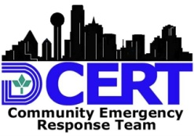
Dallas CERT Message Form
To: | Message Center Use Only
 | Incident :________________________________
From:
Time:__________________

Date:__________________
Time: | Time:__________________  Date:__________________
 | Circle one: Incoming / Outgoing
Message Text:
Action Taken:

USE CLEAR CONCISE TEXT
Examples: assignment completed / additional resources needed / unable to complete / special information / status update
Dallas CERT 004 Message Form

