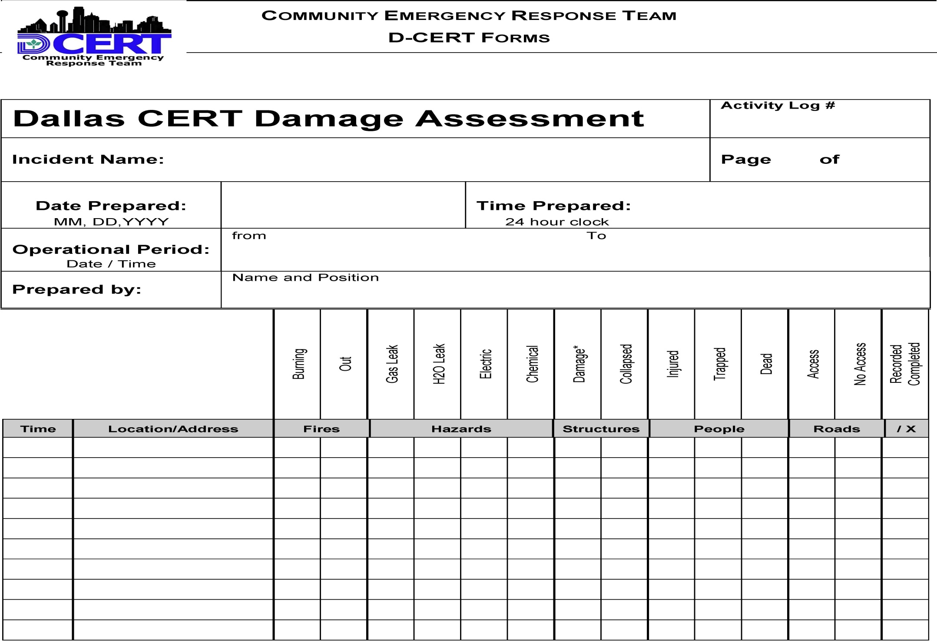
Dallas CERT 001 -Damage Assessment FOR USE BY EVERYONE

Summary of all hazards in area -fill out this form on your way to Command Post and give it to Incident Command.
(* for structure damage: h=heavy, m=moderate, l=light) Incident Command: For each location, put a slash in the Recorded / Completed column. Copy the Address / Location to the Address / Location on the Assignment Status form. Complete the Operational Task Sheet and forward to the Operations Chief for assignment to an appropriate team.

